**Lab Report**

Title: Lab 2 (Part 2)

Notice: Dr. Bryan Runck

Author: Mattie Gisselbeck

Date: November 2, 2022

**Project Repository:** <https://github.com/mgisselbeck/GIS5571>

**Google Drive Link:** N/A

**Time Spent:** 15 hours

**Abstract**

The objective of this analysis is to “create a surface that shows places where Dory would more or less prefer to walk in order to get to the park within Dory’s preferences.

Required Data and Input Data

Methods

Results

Results Verification

Discussion and Conclusion

**Problem Statement**

The objective of this analysis is to “create a surface that shows places where Dory would more or less prefer to walk in order to get to the park, within Dory’s preferences: (1) Dory prefers to not walk through any farm fields, (2) she doesn’t like crossing water bodies if there isn’t a bridge (though sometimes she doesn’t mind if she’s wearing her waders), and (3) prefers a path with the most gradual slope” (Runck, 2022).

*Table 1. Required Data*

|  |  |  |  |  |  |  |
| --- | --- | --- | --- | --- | --- | --- |
| **#** | **Requirement** | **Defined As** | **(Spatial) Data** | **Attribute Data** | **Dataset** | **Preparation** |
| 1 | County Boundaries in Minnesota | Wabasha, Winona, and Olmstead County | .shp (Vector) | N/A | [Minnesota Geospatial Commons](https://gisdata.mn.gov/dataset/bdry-counties) | ETL |
| 2 | 2012 Assessed Streams | Assessed Streams for Minnesota in 2012 | .shp (Vector) | N/A | [Minnesota Geospatial Commons](https://gisdata.mn.gov/dataset/env-assessed-streams-2012) | ETL |
| 3 | NCLD 2019 Land Cover, Minnesota | Land Cover Classification for Minnesota | TIFF (Raster) | Land Cover Classification | [Minnesota Geospatial Commons](https://gisdata.mn.gov/dataset/biota-landcover-nlcd-mn-2019) | ETL |
| 4 | Minnesota Digital Elevation Model - 30 Meter Resolution | Elevation (Wabasha, Winona, and Olmsted County) | TIFF (Raster) | Elevation | [Minnesota Geospatial Commons](https://gisdata.mn.gov/dataset/elev-30m-digital-elevation-model) | ETL |
| 5 | Roads, Minnesota, 2012 | Road Centerlines for all Public Roads in Minnesota | .shp (Vector) | N/A | [Minnesota Geospatial Commons](https://gisdata.mn.gov/dataset/trans-roads-mndot-tis) | ETL |

**Input Data**

The table below is a collection of data from the Minnesota Geospatial Commons. Data was scraped through an ETL in ArcGIS Pro via a Python notebook. All the data described below will be used in a cost path analysis to find an optimal route for Dory.

*Table 2. Input Data*

|  |  |  |  |
| --- | --- | --- | --- |
| **#** | **Title** | **Purpose in Analysis** | **Link to Source** |
| 1 | County Boundaries in Minnesota | To be used in the cost surface equation to find the most optimal route for Dory | [Minnesota Geospatial Commons](https://gisdata.mn.gov/dataset/bdry-counties) |
| 2 | 2012 Assessed Streams | To be used in the cost surface equation to find the most optimal route for Dory | [Minnesota Geospatial Commons](https://gisdata.mn.gov/dataset/env-assessed-streams-2012) |
| 3 | NCLD 2019 Land Cover, Minnesota | To be used in the cost surface equation to find the most optimal route for Dory | [Minnesota Geospatial Commons](https://gisdata.mn.gov/dataset/biota-landcover-nlcd-mn-2019) |
| 4 | Minnesota Digital Elevation Model - 30 Meter Resolution | To calculate the slope and add the output into the cost surface analysis to find the most optimal route for Dory | [Minnesota Geospatial Commons](https://gisdata.mn.gov/dataset/elev-30m-digital-elevation-model) |
| 5 | Roads, Minnesota, 2012 | To be used in the cost surface equation to find the most optimal route for Dory | [Minnesota Geospatial Commons](https://gisdata.mn.gov/dataset/trans-roads-mndot-tis) |

**Methods**

Dory’s Farm: 44.127985, -92.148796

Picnic Area in Whitewater State Park: 44.054852, -92.045780

Based on Dory’s preferences, the objective is to find a path that avoids farm fields, water bodies without a bridge, and has a gradual slope. The starting point, Dory’s Farm, is 44.127985, -92.148796 and end point, picnic area in Whitewater State Park, is 44.054852, -92.045780.

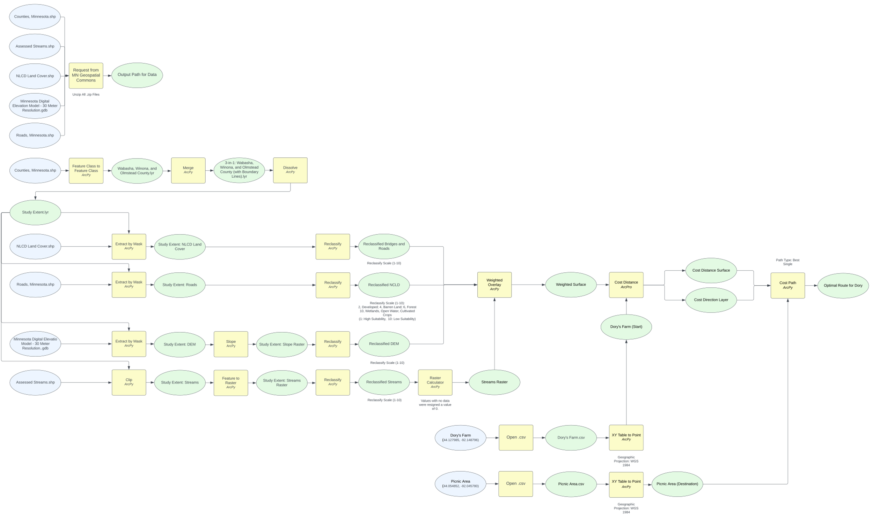

*Figure 1. Data Flow Diagram – Part 2. (Note:* .ipynb for Part 2).

**Results**

The results are shown in the figures below (see Fig. 3 through Figure 8). The main themes of the lab were preparing data in an ETL pipeline, creating a cost surface to find an optimal route. The data flow diagram above (Fig. 1) shows all the variables and commands I applied in finding an optimal route for Dory.

**Results Verification**

*How do you know your results are correct? This can be a qualitative or quantitative verification.*

**Discussion and Conclusion**

*What did you learn? How does it relate to the main problem?*

**References**

Runck, B. 2022. GIS 5571: Lab 2.

**Self-score**

|  |  |  |  |
| --- | --- | --- | --- |
| **Category** | **Description** | **Points Possible** | **Score** |
| **Structural Elements** | All elements of a lab report are included **(2 points each)**:  Title, Notice: Dr. Bryan Runck, Author, Project Repository, Date, Abstract, Problem Statement, Input Data w/ tables, Methods w/ Data, Flow Diagrams, Results, Results Verification, Discussion and Conclusion, References in common format, Self-score | 28 |  |
| **Clarity of Content** | Each element above is executed at a professional level so that someone can understand the goal, data, methods, results, and their validity and implications in a 5 minute reading at a cursory-level, and in a 30 minute meeting at a deep level **(12 points)**. There is a clear connection from data to results to discussion and conclusion **(12 points)**. | 24 |  |
| **Reproducibility** | Results are completely reproducible by someone with basic GIS training. There is no ambiguity in data flow or rationale for data operations. Every step is documented and justified. | 28 |  |
| **Verification** | Results are correct in that they have been verified in comparison to some standard. The standard is clearly stated **(10 points)**, the method of comparison is clearly stated **(5 points)**, and the result of verification is clearly stated **(5 points)**. | 20 |  |
|  |  | 100 |  |